July 9, 2025
Report
from the Strategic Council

From: To:
Jason DeMarco, AIA AIA, Hawaii, AIA Honolulu, AIA Maui
Strategic Councilor, AIA Hawaii Month Board Meeting
jason@polyline.design

Mission: The AIA Strategic Council advances the architectural profession by informing the AIA Board and other Institute bodies about important professional issues, opportunities, and threats. The Council has an outward and forward-focused vision with an emphasis on long-term goals and outcomes.

What Does the Strategic Council Do? To learn more about the role and activities of the Strategic Council, click HERE.

From the Councilor

Please encourage members you know to apply to fill this important Strategic Council position for the 2026-2029 term.

Congratulations to our own Jason Takeuchi, AIA, as a 2026 – 2028 At-Large Director!

From the Moderator + Vice Moderator
We had a great time at AIA25 in Boston! Our Conference experience kicked off with a full Council assembly and an engagement session with the Strategic Plan consultant before heading to the AIA Business Meeting. Councilors Ayo Yusuf and Mike Daly presented the AI Resolution at the meeting, which passed through the member delegate vote by 99%.

On Thursday, we had a one hour engagement session at the AIA Booth – it was wonderful to meet with prospective future Councilors and talk about our areas of study with conference attendees. If you would like a copy of that slide presentation, please reach out to your state representative on the Council. Many of our study groups are still gathering feedback to inform their work – QR codes can be found below and will remain open until 7/30/25.

We also held an informal 10-year anniversary celebration in Boston – thank you to everyone who came out for that. More anniversary highlights to come!

Looking ahead, the Council will be hosting internal elections this summer, along with elections for the At-Large Representatives to the Council. We have also scheduled our study group report outs for August and September, which will wrap up before our September Council Assembly.

Jessica M. O’Donnell, AIA 2025 Moderator + Abigail R. Brown, FAIA 2025 Vice Moderator
Special thanks to our committee chairs who help guide our work and inform our decision-making process: Jeff Seabold, FAIA (Best Practices Committee Chair), Mary Womble, AIA & Marc Mondor, AIA (Communications Co-Chairs), and Mike Daly, AIA (Elections Chair).
Council News

STUDY GROUP UPDATES
AIA OF THE FUTURE
This group is streaming through the S.W.O.T. analysis materials received from multiple AIA components. They are also assessing ways that AIA can increase its impact and influence through a broader and wider reach without dilution the voice of the architect. Finally, they are exploring issues of governance in collaboration with the 10 Year Valuation committee.
ARCHITECT OF THE FUTURE
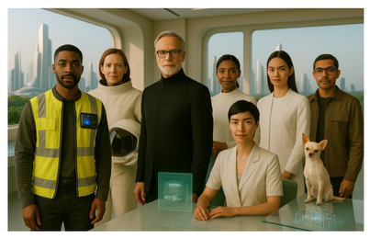 | Check out their persona video and share your thoughts on what inspirations will drive a future architects career, what types of communities or clients future architects will work with, and what values will guide our future design philosophy. Survey is open until 7/30/25.
 | 
CLIMATE RESPONSIVE DESIGN & LEADERSHIP
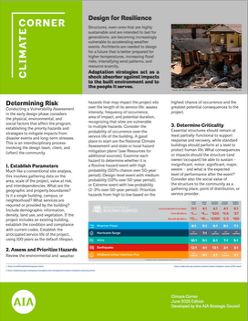 | This group continues to research and release its monthly Climate Corners, and the entire study group is collaborating to tackle the various topics chosen.  ENHANCE YOUR SUSTAIN-ABILITIES this June with resilience and climate risk assessment - a threat assessment protocol for designing buildings that can perform at the highest level with regards to mitigating the most pressing threats; contextual to its geographic region, and the subsequent "priority climate risks". Link to the PDF can be found here.  The July effort will begin to investigate the 'hot topic' of regenerative design, and how defining this can help us build a trajectory for future study.
CONNECTED COMMUNITIES
This study group is developing a needs matrix to address how architects – specifically public architects – can meet the needs of communities (of all sizes) through leveraging existing resources, identifying case studies for cross collaboration, and developing solutions that enhance the role architects play in public life through design thinking. The needs matrix will assess components of housing, technology, and equitable community development.
DIGITAL ARCHITECTURE
With the affirmative vote on the AI resolution at the Annual Business Meeting, this study group is focusing efforts on their research into the impact of AI on business practices, AI equity between large and small firms, and the relationship between AI and the environment. This group is also coordinating ongoing efforts with AIA’s AI Task Force.
RESILIENT PRACTICE MODELS
 | This group continues to dive into external, internal and professional pressures on practice. Their survey seeks input from business leaders in firms and will remain open until 7/30/25.  In the next few weeks, this group will wrap up their initial exploration into the impact of the recent executive orders on practice and send that report to the AIA Board.
10-YEAR VALUATION & FUTURE BLUEPRINT
The final slate of interviews has just concluded. Over the next two months, this group will assess, synthesize, and identify areas of consensus from the interview feedback which will then inform their recommendations to the Governance Task Force and the AIA Board.

The 2025 AIA Strategic Council during our in-person assembly meeting at AIA25!

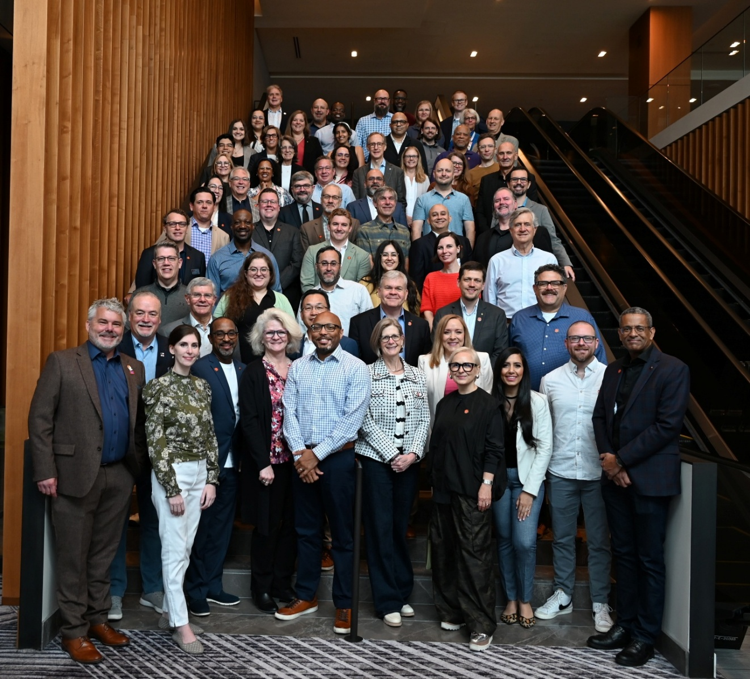
Institute News
AIA25 – CONFERENCE ON ARCHITECTURE & DESIGN RECAP
- The AIA Annual Business Meeting was held on Wednesday, June 4, 2025, during the first day of AIA25. The AIA Artificial Intelligence Policy Resolution passed with 99% of the vote, as well as other Bylaws Amendments that were included in the AIA official delegate booklet. More information regarding the Annual Business Meeting can be found here.
- Three new leaders were elected to the AIA Board of Directors.
  - Yiselle Santos Rivera, AIA, 2026 President-elect/2027 President;
  - Jason Takeuchi, AIA, as 2026 – 2028 At-Large Director;
  - Lisa L. Kennedy, FAIA, as 2026–2027 Treasurer.
- The 2025 AIA Award Recipients were announced during the AIA Awards Gala in 11 award categories. The winners for each category can be found here.
- Recaps of Day 1, Day 2 and Day 3 keynotes can be found at the links provided.

Upcoming events
Date | Event | Location | Link
July 16-17 | Architects in Action | Virtual
November 3-5 | Women’s Leadership Summit | Atlanta, GA
December 3-5 | AIA Governance Week | Washington, D.C.

For more events, visit the AIA events page at: https://www.aia.org/community/events

Feedback
We value your input! If you have questions or ideas for the Strategic Council, email us at StrategicCouncil@aia.org.
To learn more about the work of the Strategic Council, please visit the Strategic Council webpage at AIA.org.

